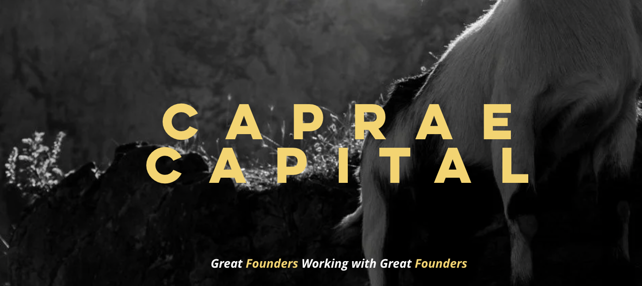

Full Stack Developer Interview Pre-Work

Private & Confidential

Kevin Hong
Managing Principal
Caprae Capital Partners

Note from the Founder
First off, before you begin our handbook and kick off Caprae Capital’s interview process, I want to congratulate you for being pre-selected. We receive 10s of thousands monthly and it is not always easy for us to select the right candidates. Of course, many candidates, given the workload for the handbook, do not finish; hence there is some skewness in the data set so please do not be too intimidated.

In a nutshell, Caprae Capital looks for several characteristics. We pride ourselves on bringing in talent who can and have the desire to change the world someday. As we have refined our interview process over time, I have simplified what we look for in a candidate - character, courage, creativity… and if applicable, crazy. By crazy, we mean this in a good way - a burning desire and the mental and physical stamina to take the time to master one’s craft and become world-class in what they do.

While many programs measure a candidate's potential by school pedigree, academic track record, and prior experience, I do believe the secret to recruiting is “finding the talent” before it's written on the resume. We look for independent thinkers, those who are never afraid to question, and avoid those who look at their careers as a means to an end, a vehicle for a fat payday, or a nice trophy to stamp on their resume. Therefore, every step of our interview process is quite intentional and is aimed at seeking out the right candidates who can thrive in our system.

Of course, not everyone can maximize his or her potential here, but for the ones that have great upside, I try to part the red sea as much as I can. At the end of the day, when comparing talent vs experience, I liken this to comparing horsepower vs mileage. At Caprae Capital, we love horsepower.
Although I do not always interview candidates directly, I wish you the best of luck during the interview process and appreciate all the time you will be spending to get to know us. I hope to meet you on the other side and look forward to building a world-class company together.

Thanks,
Kevin

PS - Although we are a finance firm, we are a founder/operator first company. While companies and countries may come and go, culture remains. PLEASE READ our founder’s latest post and what we are trying to accomplish through corporate governance as well as humor. Also, view our webinar to hear directly from our team about Caprae’s mission, vision, and culture.

Table of Contents

Note from the Founder 2
Welcome to the AI-Readiness Pre-Screening Challenge! 4
1. Development Challenge Overview 4
2. Submission Requirement 5
3. Evaluation Criteria 5
4. Business Understanding 6
5. Submission 7
6. Deadline 7
7. Reapplicants 7

Welcome to the AI-Readiness Pre-Screening Challenge!
Caprae Capital's vision extends beyond traditional investing — unlike most PE firms, which heavily rely on financial engineering, we're dedicated to transforming businesses through strategic initiatives. One critical piece of that transformation is helping companies embrace and leverage AI to unlock new growth opportunities.
Our SaaS (Software as a Service) and MaaS (M&A as a Service) models are designed to empower businesses post-acquisition. (Yes, that is correct. We think of M&A as a seven-year journey as the greater value creation is post-acquisition not at the time of acquisition.
By introducing practical AI solutions, we help companies improve decision-making, streamline operations, and ultimately create lasting value. This AI-readiness challenge is a reflection of that mindset — it’s not just about technical skills but about demonstrating how AI can drive real-world impact. By combining technology with our unique support model, we aim to turn good businesses into great ones.
References that can be helpful
- SaaSquatch, explained by the person who built it: what it pulls from and why we use it as our primary sourcing tool 👉 Direct Link
- Early traction on SaaSquatch (1,200+ users, 30+ paying customers in 3 weeks). Proof it's a live, growing tool, not a side project 👉 Direct Link
- The story behind SaaSquatch and why Caprae builds its own tools instead of renting someone else's 👉 Direct Link

1. Development Challenge Overview
We are looking to enhance our leadgen scraping tool:
https://www.saasquatchleads.com/
Demo video
Please analyze this business model and create a tool within the accessible features that you think could help a company in the most effective way possible with just 5 hours of code.
Game Rules: Building a Better Lead Generation Tool
- Analyze with Intent: Begin by thoroughly studying the reference application, focusing on its features, functionality, and overall design. Gain a clear understanding of its strengths, limitations, and business purpose.
- Strategic Development Focus: Dedicate no more than 5 hours to engineer one or two impactful features for the tool. You can choose between two approaches:
  - Quality First: Focus on enhancing a specific feature to improve performance, accuracy, or usability.
  - Quantity Driven: Develop multiple lightweight tools that replicate or expand upon the original concept to maximize output.
- Articulate Your Rationale: Conclude by presenting a concise, 2-minute video detailing your design choices. Highlight the feature(s) you chose to replicate or improve, why they add value, and how they align with real-world business needs.
- Engineer with Excellence: Detail your UX design choices and full backend architecture - including your data storage strategy (specific database used), caching and performance optimizations, hosting setup (static vs. serverless), deployment process, and cloud provider (e.g., AWS, GCP, Azure). Specify the exact technologies and frameworks used throughout the stack.

2. Submission Requirement
- GitHub Repository: Containing all relevant code, a README.md with setup instructions, and the dataset (if permissible).
- Video Walkthrough: Submit a 1-2 minute video explaining your project, the value it generates, decisions you made, and results.
- Demo Link (optional but recommended): Provide a Jupyter Notebook walkthrough or API demonstration if feasible within the time limit.

3. Evaluation Criteria
Your work will be assessed based on:
- Business Use Case Understanding (10 points):
We are looking for a tool that demonstrates a clear understanding of the lead generation process, aligning with real business needs. The solution should reflect strong business acumen, identifying key data points that are valuable for sales outreach. Points will be awarded based on the tool's ability to prioritize high-impact leads, minimize irrelevant data, and integrate seamlessly into existing sales workflows. Tools that align closely with our target market, customer personas, and sales strategy will score highest. Creative approaches that go beyond simple scraping to deliver actionable insights are highly encouraged.
- UX/UI (10 points):
The tool should prioritize user empathy, offering a clean and intuitive interface that simplifies data collection and management. We are looking for seamless navigation, clear data presentation, and minimal learning curves for users. Points will be awarded for thoughtful design decisions that reduce complexity, enhance usability, and improve overall user experience. Tools that effectively guide users through key processes—like filtering, exporting data, or verifying leads—will stand out. Exceptional submissions may also offer smart automation or workflow enhancements that improve time efficiency.
- Technicality (10 points):
The tool should demonstrate technical sophistication, efficiently extracting accurate and relevant data from multiple sources. Points will be awarded for effective data parsing, reliable performance at scale, and the ability to handle complex web structures. Bonus points will be given for features that improve data quality, such as deduplication, enrichment, or validation. Solutions that show flexibility in adapting to changing websites, CAPTCHAs, or IP restrictions will be particularly strong. Tools that combine technical rigor with speed and scalability will score highest.
- Design (5 points):
Visual presentation should be clear, professional, and thoughtfully organized. Points will be awarded for effective use of color, typography, and layout to improve usability. While simplicity is key, the design should feel polished and purposeful, aligning with modern software aesthetics. Submissions that effectively use visual cues to improve navigation, highlight key actions, or organize data will stand out. Exceptional designs will blend functionality with aesthetic appeal to create a positive first impression. _
- Other (5 points):
This category rewards creativity, innovation, and unexpected value-adds that improve the tool’s effectiveness. Points may be awarded for features like automated reporting, CRM integrations, or unique filtering capabilities. Tools that demonstrate an extra layer of thoughtfulness, such as ethical data collection practices or insights for sales strategy, will also score well. Exceptional presentations, clear documentation, and well-articulated product strategies will be recognized. Above all, we are seeking solutions that deliver high-impact results efficiently.

4. Business Understanding
In no more than 3-4 paragraphs each, please answer these three questions.
- What is Caprae’s Mission?
- Why do you want to work at Caprae Capital?
- How is Caprae Changing the ETA Space and Broader PE?
Please provide a brief answer to each of the following questions:
- What is your current working status in the US?
- Are you willing and able to work a minimum of 40 hours/week?
- Why Caprae Capital?
- What is your expected salary?
Please confirm that you understand the basic employment expectations outlined below:
- There will be a 3 month probationary period when you start
- You are expected to work 9AM-6PM EST with a 1-hour lunch break during the initial training program (2-3 months)
- You are expected to be available during off hours in case of any customer service-related emergencies + time sensitive projects (fewer than ~2 hours week if any) would this be an issue for you? After training, you will likely have more flexible hours based on your local time zone.
- Please confirm if this is ok with you?

References that can be helpful
- Inside Caprae: our first public career webinar, hear directly from the people building the firm 👉 Direct Link
- What we actually stand for, in our own words 👉 Direct Link
- Six Months at Caprae Capital: What Actually Matters, a first-person look at life inside the firm 👉 Direct Link
- Caprae Substack
  - What Matters
  - Speed of Communication
- Search Fund CEO Termination Issues
- #BleedandBuild
- Recruiting Video
- SaaSQuatch

5. Submission
Once you have completed the assignments above, please gather up all of your submission material and send it in an email to: recruiting@capraecapital.com
Ensure that your Subject Line is: “{Role Title} - Handbook Submission - {Your Name}”
Please include an up to date copy of your resume with your submission.

6. Deadline
Once submitted, your handbook will be evaluated. If you receive a satisfactory score, you will receive an interview invite for a 10-minute screening interview within 2-3 business days. If not a final offer depending on your stage. Only handbooks that have passed will receive an invite for the next steps. Candidates that pass, must be able to start immediately. For those who desire to postpone their start date must reapply. Reapplicants must wait at least 6 months before reapplying. For those that fail the handbook, unfortunately you will unlikely receive a notification. Caprae receives 1000s of applicants and it is not always possible for our staff to follow up with all candidates. To allow for parity in the interview process, extensions will not be allowed.

7. Reapplicants
Keep in mind you can only apply up to 3X per year.
Please include answers to these additional questions if you are a reapplicant.
- What do you think is Caprae’s unfair advantage?
- What does “To become a legend, you must take down legends” mean to you?
- What do you think Caprae’s culture will be like?

Good luck!

